
Year 11 Specialist Mathematics
Test 2 2020
Chapters 3, 4, 5

Name: Time: 25 minutes Total / 25

INSTRUCTIONS:
Part A: Non-calculator
Notes not allowed
Full working must be shown for all questions (or parts) worth more than 2 marks.
Marks will be deducted for rounding and unit errors.

Question 1 ( 7 marks )
Given that 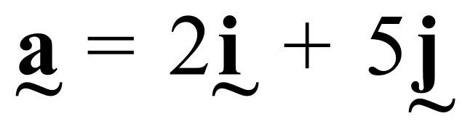 and 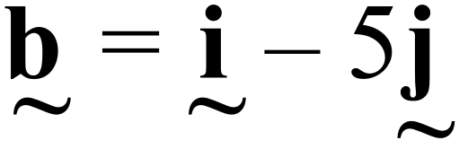 find
a) 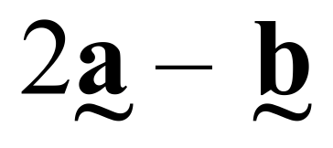 [1]

b) 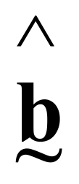 [1]

c) vector  such that 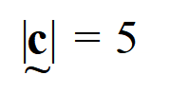 and 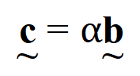 [2]

d) a vector of magnitude 10 moving in the opposite direction to 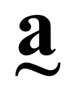 [3]

Question 2 ( 5 marks )
In a triangle ABC, P is the midpoint of BC. Prove that 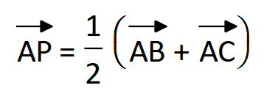

Question 3 ( 1, 1, 2, 2 = 6 marks )
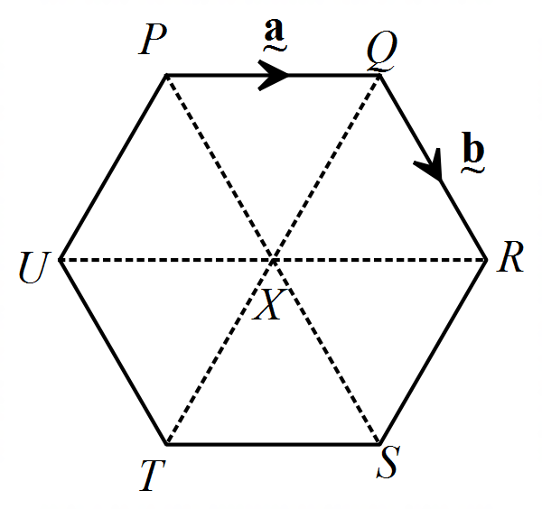PQRSTU is a regular hexagon. If 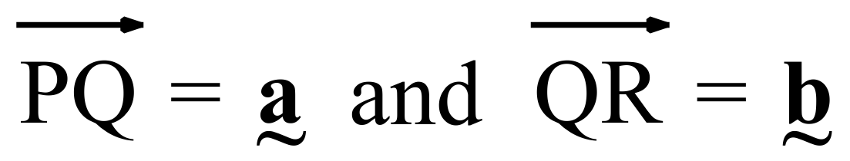, find in terms of  and 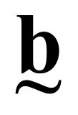
- 

- 

- 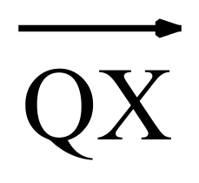

- 

Question 4 (3 marks)
In the diagram 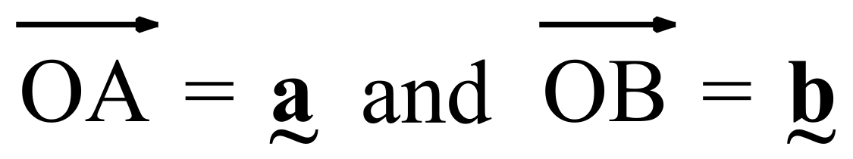 .
Point P divides OA in the ratio OP : PA = 4 : 1.
Point Q divides AB in the ratio AQ : QB = 2 : 3.

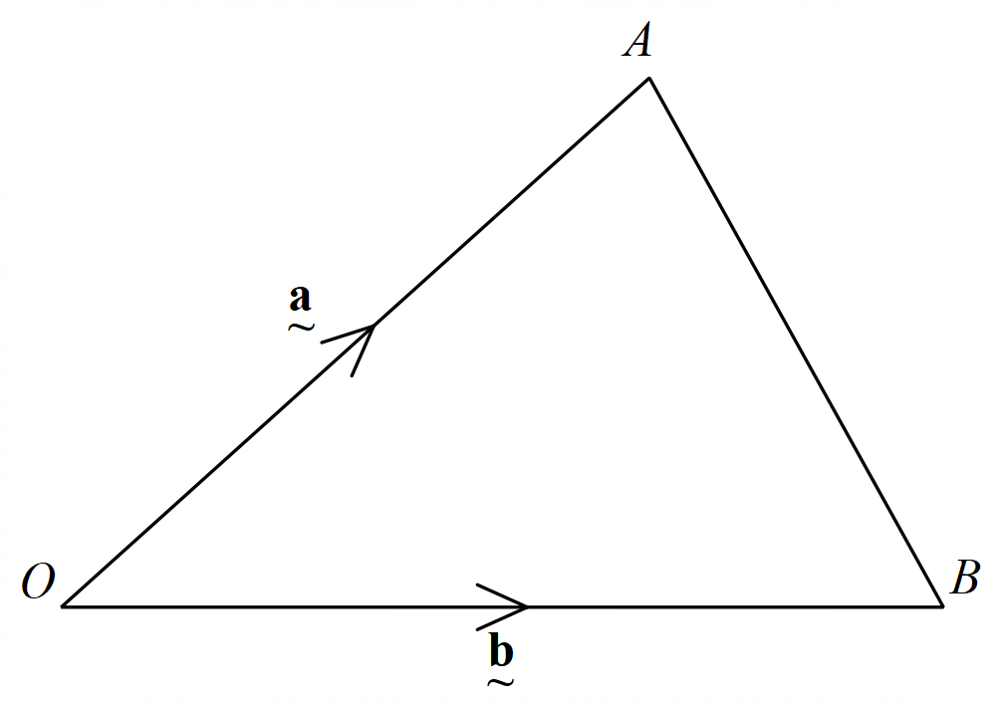Show that 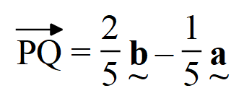

Question 5 (4 marks)
Points A, B and C have position vectors 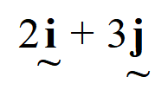 , 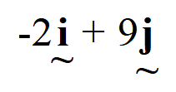 and 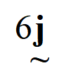 respectively. Use vectors to prove that the points A, B and C are collinear.


Year 11 Specialist Mathematics
Test 2 2020

Name: _______________________________ Time: 30 minutes Total / 25
INSTRUCTIONS:
Part B: Calculator allowed
1 page of A4 notes allowed
Full working must be shown for all questions (or parts) worth more than 2 marks.
Marks will be deducted for rounding and unit errors.

Question 1 ( 5 marks )
Find the value of all pronumerals, giving reasons (O is the centre of the circle, AB is a tangent)
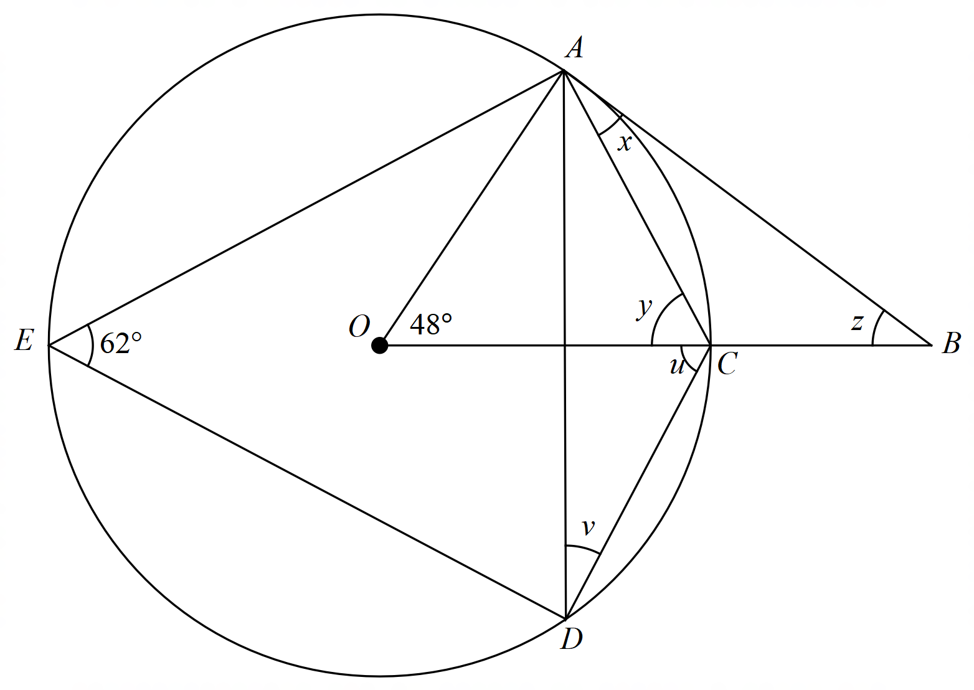

Angle/working | Reason
Question 2 (3 marks)
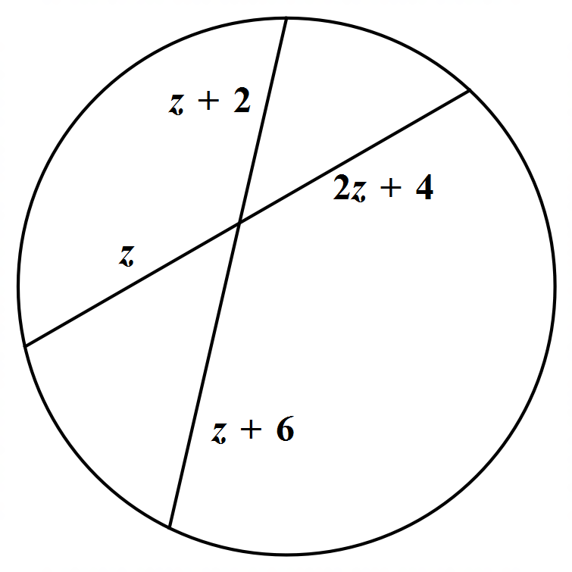Find the value of the pronumeral z

Question 3 (4 marks)
GFH is a common tangent to both circles. Prove that LK is parallel to NM
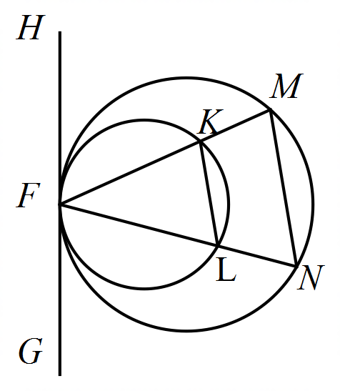

Question 4 (4 marks)
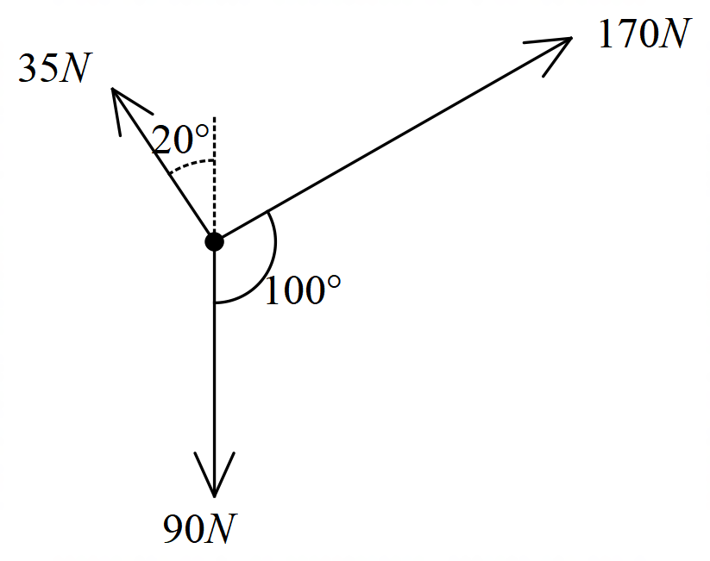Find the resultant of the set of vectors below, giving your answer in the form 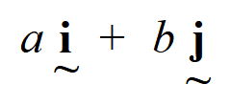

Question 5 (2, 3 = 5 marks)
A river of width 100 m where the current flows at 4.5 km/h is shown in the diagram. A boat is to be driven directly across the river from point P to Q. The boat has a speed of 12 k/h in still water.
- Determine the angle to the bank in which the boat must be directed

- How long will the journey take?

Question 6 (5 marks)
In the diagram below, FCG is a tangent to the circle ABC.

BD bisects 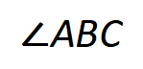 and CD bisects 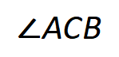
BE bisects 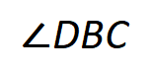 and CE bisects 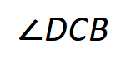

If AB = AC and 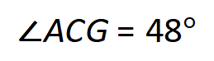 , determine the ratio, in simplest form, of 